End of Year 12 Test analysis Name: ____________________________

|  |  |  |  |  |  |  |  |  |  |  |  |  |  |  |  |  |  |
| --- | --- | --- | --- | --- | --- | --- | --- | --- | --- | --- | --- | --- | --- | --- | --- | --- | --- |
| Question number | Topic | Marks out of: | My mark | Reasons for not achieving full marks (tick applicable) | | | | | | | | | | | | | |
| RTQ! | | Calculation errors / accuracy | | Lack of full/ correct labelling or “detailed reasoning” | | Problem understand-ing the topic | | Lack of revision | | Failing to simplify answers | | Misreading numbers (e.g. from previous answers) | Other (give details) |
| **Further Maths: 79 marks** | | | | | | | | | | | | | | | | | |
| **1** | Roots of a cubic; Argand diagram | 6 | 5 |  | |  | | x | |  | |  | |  | |  |  |
| **2** | Roots of polynomials | 6 | 6 |  | |  | |  | |  | |  | |  | |  |  |
| **3** | 3x3 matrix determinant, inverse, simult. eqns. | 8 | 8 |  | |  | |  | |  | |  | |  | |  |  |
| **4** | Discrete random variable | 12 | 8 |  | | x | | x | |  | |  | |  | |  |  |
| **5** | Complex numbers | 7 | 7 |  | |  | |  | |  | |  | |  | |  |  |
| **6** | Matrices (invariant lines, scale factors) | 12 | 8 |  | |  | |  | |  | |  | |  | |  | Forgot to give c |
| **7** | Vectors (angles and lines) | 11 | 3 |  | |  | |  | |  | | x | |  | |  |  |
| **8** | Bivariate data (regression) | 12 | 9 |  | | x | |  | |  | | x | |  | |  |  |
| **9** | PMCC calculation and test | 5 | 3 |  | | x | |  | |  | | x | |  | |  |  |
| **TOTAL** | | **79** | 57 |  |  | |  | |  | |  | |  | |  | |  |

Mean percentage per question achieved across the cohort:  


EoY12 Further Maths

Comments about individual questions

**Q1:** **(a)** It is not enough to write $f\left(-1\right)=0$. You need to give evidence of substituting -1 into the correct formula and really finding it is 0.

**(b)** Make sure, when writing an equation which you are solving that you put “ = 0 ” and label your solutions $x=…$ This is a “show detailed working” question, so show how you solve the quadratic.

**(c)** The Argand diagram is also called the Complex Plane. Complex numbers are denoted by points but are usually labelled in $a+b\text{i}$ form

**Q2:** **(b)** You were expected to use what you know of roots and coefficients and the answer to part a to do this, not to solve the first equation and use the roots to try to find a second equation. Those who tried the latter method got into a nasty mess. $8x^{2}-x+12$ is not an equation. $8x^{2}-x+12=0$ is.

**Q3:** **(a)** If you are “showing” the determinant is $1+a$, there must be some clue of what you are doing. Don’t jump to the third line in your head. Best to start with a first line such as $2\left|\begin{matrix}3 & 2 \\ 2 & 5\end{matrix}\right|-a\left|\begin{matrix}1 & 2 \\ 3 & 5\end{matrix}\right|+3\left|\begin{matrix}1 & 3 \\ 3 & 2\end{matrix}\right|$ so that it is clear which row or column you are expanding by. Something like $"11×2-a×-1+3×-7=1+a$” doesn’t really “show” much.

**(b)** A correct answer with no working gained 0 marks.

**(c)** Students who did not use their “result to part (b)” to solve the equations, as required in the question, could not gain any marks, even if they did everything correctly and found the solution.

**Q4:** **(a)** Remember that all probabilities must lie between 0 and 1.

**(b)** If you are showing that E(X) is independent of *k*, it is not enough to show E(X) = 3.4, you must also make a comment to show that you understand that this is independent of *k*.

**(c) i.** X is a discrete random variable. We are talking about probabilities, not data. So you should use this part of the formulae book  
 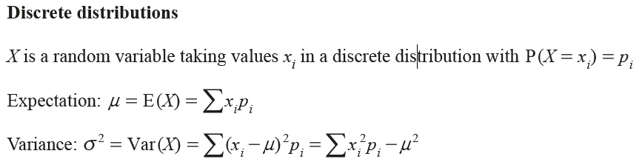  
not this bit  
 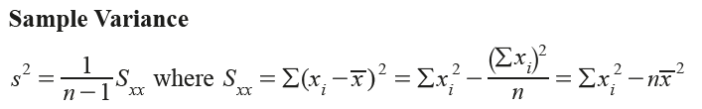

**(c) ii.** Show what you are doing. Some students had number floating unlabelled on the page. $0.2×0.3=0.12$ is true, but it is not explaining anything. Something like $P\left(X_{1}+X_{2}=6\right)=P\left(2,4\right)+P\left(3,3\right)+P\left(4,2\right)=0.2×0.6+0.2×0.2+0.6×0.2=0.28$ 
   
may not be perfect notation, but it tells the story.

**Q5:** This question was done well. Some students forgot that you can equate the real parts on either side of an equation and equate the imaginary parts.

**Q6:** **(b)** You were told in the question that you were looking for the invariant lines that went through the origin. Students who used $y=mx$ had a far easier time than those who used $y=mx+c$ and substituted $c=0$ later in their working. Please use the convention of writing two matrices next to each other to show multiplication, so that the order of multiplication is clear and put the result after an “=” sign.

**(c) i.** You were given that the original area was measured in cm2 so units were required in your answer.

**Q7:** **(a)** This part was well answered, using the scalar (dot) product. Clear labelling made it much easier to follow. Remember that vector names such as **p** and **q** are typed in bold print to show they are vectors, not scalars. You are expected to write them as p and q since you cannot do bold print.

**(b) i.** Students who used the letters on the diagram to show what they were doing made it much clearer,   
so $\vec{CD}=\vec{CO}+\vec{OD}$ gave clear evidence of understanding.

**(b) ii.** Again, those who used the letters on the diagram found it much easier to express what they were doing. Not that this and the previous question had the “answer” given, and so clear reasoning was needed.

**(b) iv.** The parameter ($λ$) in the line through CD should NOT be the same as the parameter used for the line through AB. Few students arrived at the correct position vector for E.

**Q8:** **(a)** There are many reasons which were acceptable to explain why it would not be appropriate to carry out a pmcc hypothesis test, but your comment needed to show evidence of why you thought it was not appropriate. If you say that the variables do not appear to follow a bivariate normal distribution, you must give evidence (because the points do not lie in an ellipse) and comment that this indicates that the test would be invalid.

**(b)** You were expected to use the formulae provided in the formulae book (you are not expected to memorise things like this!)  
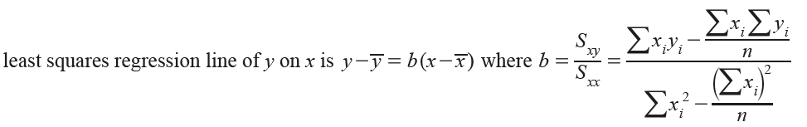

The data needed was at the top of the spreadsheet picture. 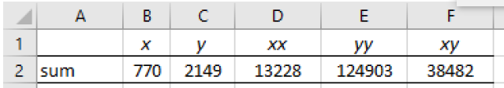

So $\sum{x_{i}}=770$ and so on.

**(c)** Units were given in the question, so units were required in the answers.

**(d)** Interpolation and extrapolation were the ideal words here (though clearly explaining the concept in other words was acceptable.) Comments on predictions from regression lines are usually about interpolation and extrapolation, so make sure you know what these words mean and use them rather than “within the data” etc.

**(e)** Be aware that if a data point is below the line of regression, the residual in negative. If it is above the line, the residual is positive.

**Q9:** **(a)** This was 1 mark and you were simply required to write down the answer. No working was asked for.

**(b)** When you define $ρ$ you must make it clear what the context is and that it is the correlation between the variables in the POPULATION. It is a good idea to copy words directly from the question to be squeaky clean, e.g. “where ρ is the population correlation coefficient between the diameter of a black cherry tree and its height”

**(c)** Part a is a bit of a “red herring” for this part; the value you need is directly given to you here. The “p-value” is the probability of totally random data comping out with a pmcc of the sample pmcc or one even closer to 1 or -1. In other words, the “p-value” in ANY hypothesis test can be compared directly with the significance level and if it is less than the significance level, you reject H0.

**Use the above to help you reflect on how your assessments went and set yourself targets below:**

What topics do I need to concentrate on in my revision?

Vectors and angles

What can I do when completing my exam to ensure that I get maximum marks for each question? (e.g. highlighting key words, labelling calculations)

Make sure to cover the whole topic in revision